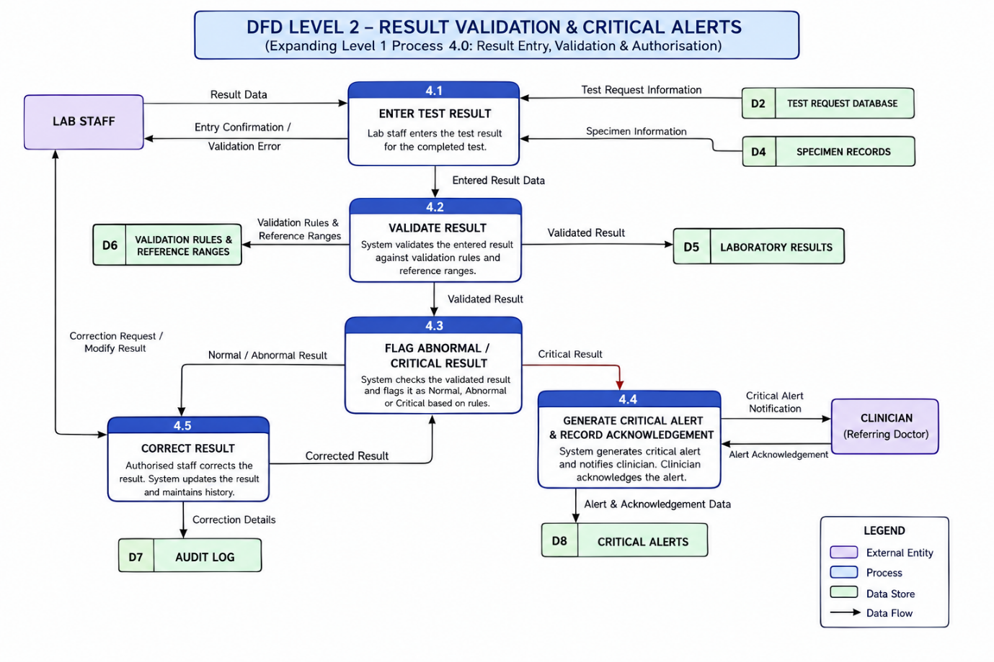
DFD Level 2: Result Validation & Critical Alerts

